HD 142022A

HD 142022A is a 0.99 M☉, K0 star1. HD 142022 is a double star system and HD 142022 B was identified as a 0.6 M☉ star with a projected binary separation around 1000 au1. Based on 70 RV CORALIE measurements obtained between 1999 and 2004 and 6 RV HARPS measurements obtained between 2004 and 2005, a study performed in 2006 (hereafter E06)1 reported a GP signal with a period of days, a minimum mass of MJup and an eccentricity of . The CH survey reported a GP signal with properties close to those reported in the E06 study.

In the present study, in addition to the E06’s dataset, 7 RV HARPS measurements obtained between 2004 and 2010 were used. DPASS and MCMC (1000 walkers and 400000 iterations) were used to fit the data. With DPASS, a GP with properties close to those of the CH survey was found. Using MCMC, a GP was found with a period of days, a minimum mass between 4 and 24MJup and an eccentricity larger than 0.47. As the RV curve of HD 142022Ab does not cover the minimum, the RV offset is not well constrained, though.

To explore the range of possible values for these parameters, the stellar offset was fixed to different values and the data, once corrected for the instrumental offsets for clarity purposes, were fitted with DPASS. Stellar offset up to -50 m/s do not significantly change the rms of the residuals (10.7 m/s against 10.2 m/s with offset left free). In this case (referred to as constrained offset), the semi-major axis is 3.04 au, the minimum mass is 35 MJup and the high eccentricity is 0.95.

The fits are shown in Fig 1, and the corner plot in Fig 2, and the results summarized in Table 1.

Conclusion: The period found for HD 142022Ab is close to those found in the CH survey. The minimum mass and eccentricity are not well constrained. Depending on the stellar offset, the companion could be a brown dwarf. Additional data are needed to further constrain the minimum mass and the eccentricity.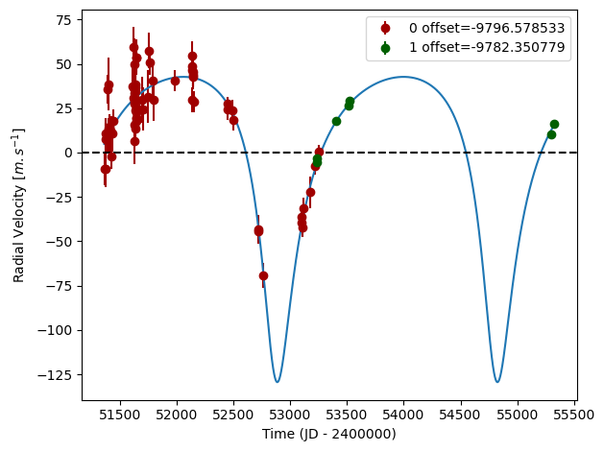

Figure 1: Left: fit of the HD 142022A RV with DPASS. Red - C98, green - H03. The blue curve shows the best fit. Middle: fit of the HD 142022A RV with DPASS, with a subtracted stellar offset fixed to -50 m/s. Black points correspond to the data corrected for the instrumental offsets. The blue curve shows the best fit. Right: fit of the HD 142022A RV using MCMC. The black curve shows the best fit. The colorbar corresponds to the log-likelihood of the fits. 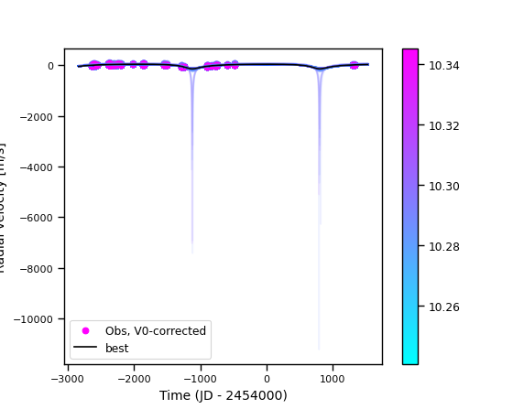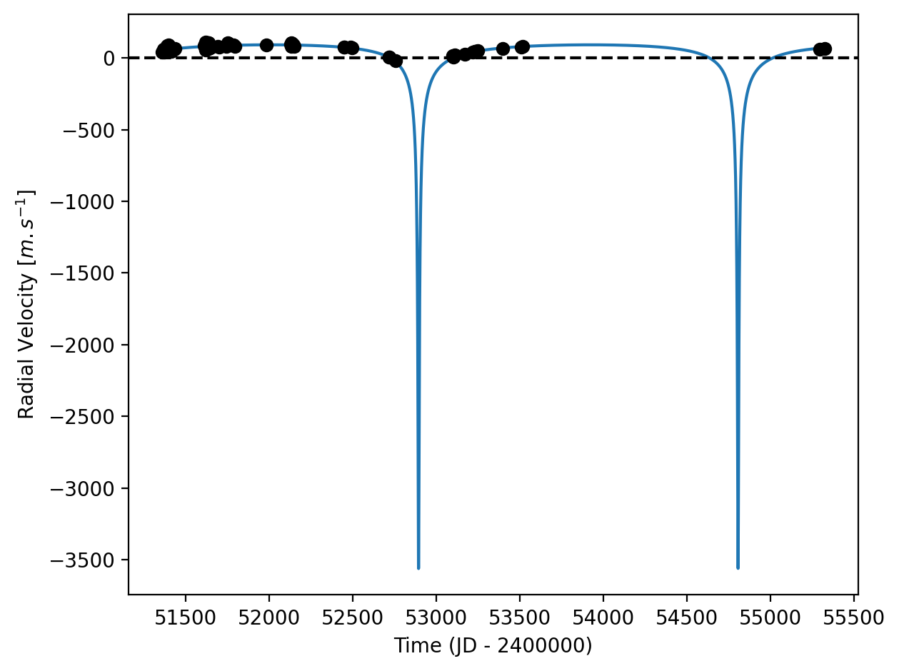

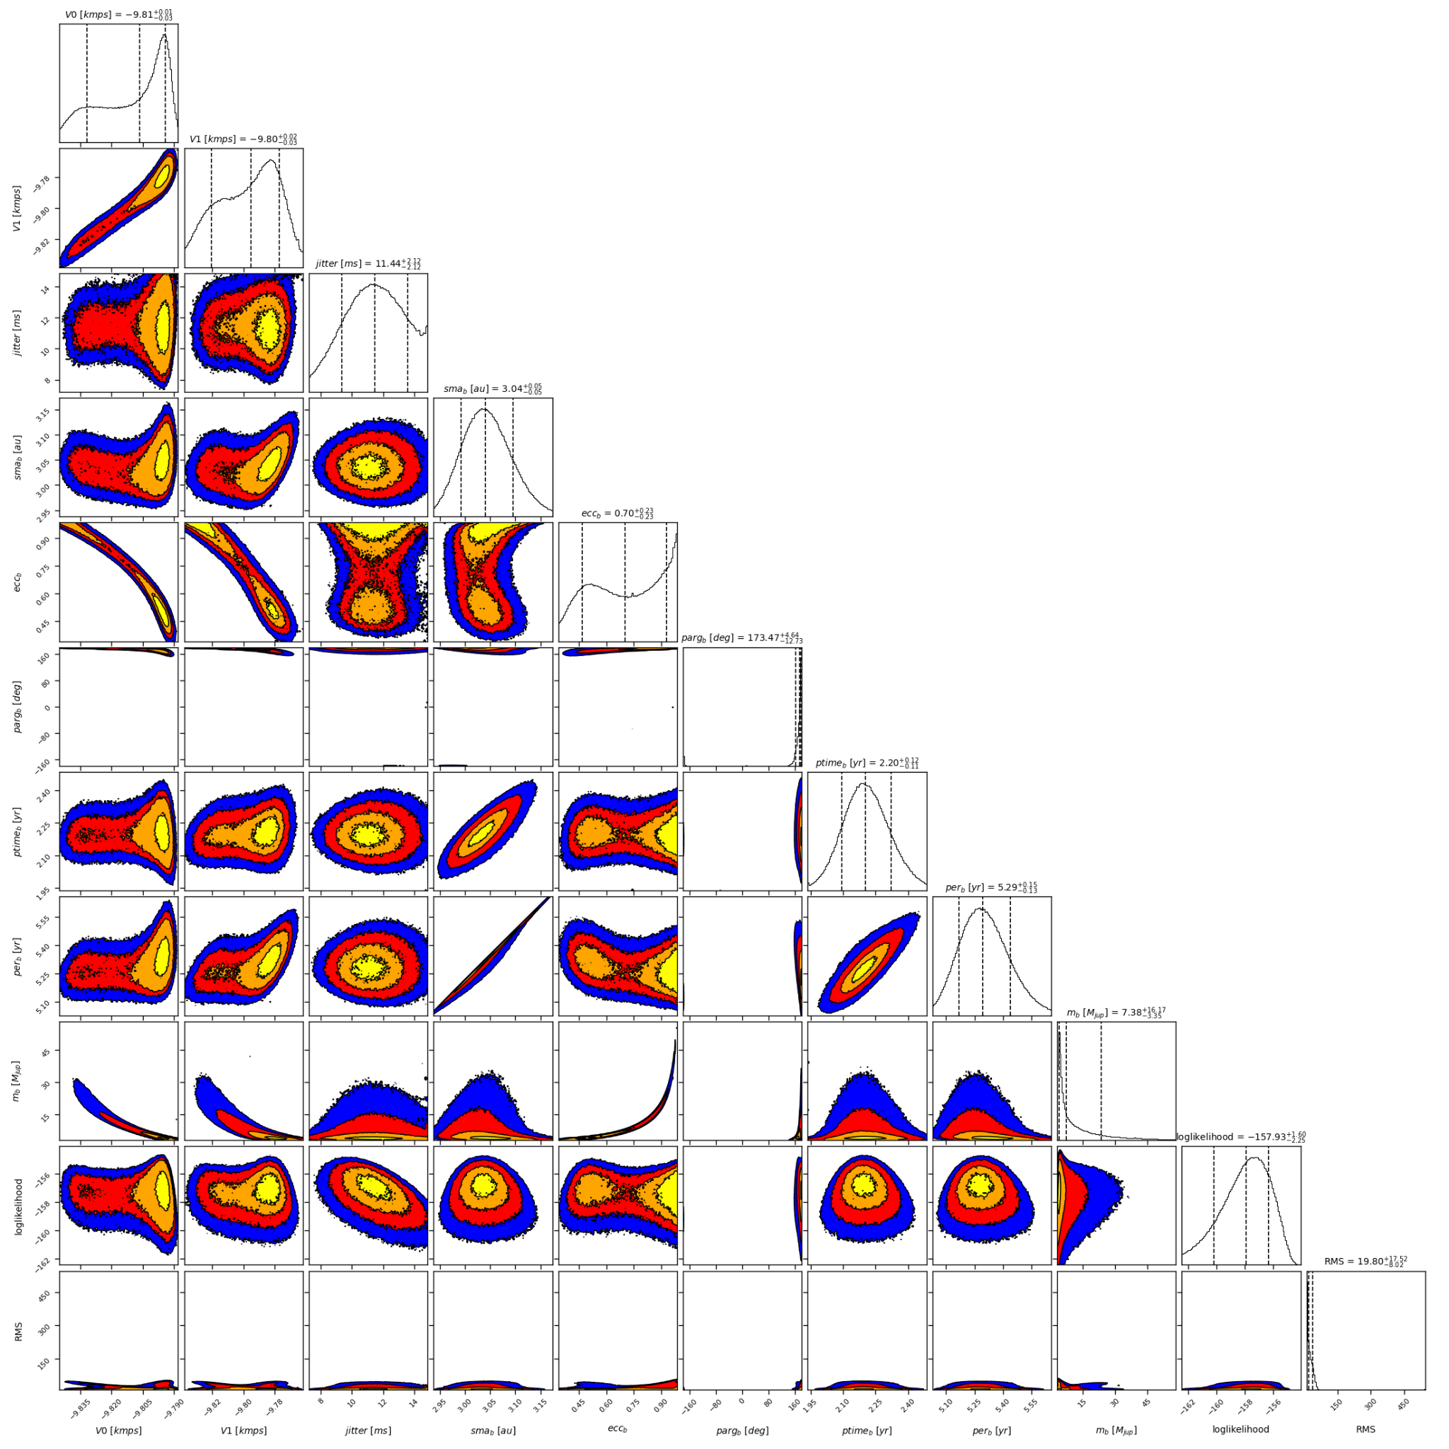

Figure 2: Corner plot of posteriors for the one-planet model MCMC fit of HD 142022A RV data.

| Parameter | Priors | | | Posteriors | | | CH survey |
| --- | --- | --- | --- | --- | --- | --- | --- |
|  | DPASS | | MCMC | DPASS | | MCMC |  |
|  | Free offset | Constrained offset | Free offset | Free offset | Constrained offset | Free offset |  |
| *a* (au) | [0,100] | [0,100] | [1,10] | 3.04 | 3.04 | 3.04+0.06-0.05 | 3 |
| Msin(i) (MJup) | [0,100] | [0,100] | [1,100] | 4.5 | 35 | 4 – 24 | 4.47 |
| Eccentricity | [0,0.95] | [0,0.95] | [0,0.99] | 0.51 | 0.95 | >0.47 | 0.52 |
| Instrumentals offsets (km/s) | [-60,60] | up to -0.050 | [-11,-9] | C98: -9.797  H03: -9.782 | -0.050 | C98: -9.832 – -9.794  H03: -9.821 – -9.777 |  |
| Stellar jitter (m/s) | [0,40] | [0,40] | [0,20] | 9.0 | 10.8 |  |  |
| Argument of periastron (°) | [0,360] | [0,360] | [0,360] | 169 | 179 | 173+12-5 |  |
| Phase | [0,1] | [0,1] | [0,1] | 0.24 | 0.67 |  |  |

Table 1: HD 142022A. Summary of priors and posteriors obtained with DPASS and MCMC, compared to the properties reported by the CH Survey.

References

1. Eggenberger, A. et al. The CORALIE survey for southern extrasolar planets XIV. HD 142022 b: a long-period planetary companion in a wide binary. *Astron. Astrophys*. 447, 1159-1163 (2006).